EnOS Edge EGC 2.4.7
Trouble Shooting Manual

Content
1. Basic Operations 4
1.1 Local Operations Interface Login 4
1.2 EGC Strategy Configuration 6
1.2.1 Creating Control Strategy 6
1.2.2 Local Operations Interface Configuration Control Strategy 7
1.3 Modify Log Level 8
1.4 Restart EGC 9
1.5 Check EGC Strategy Running Status 10
1.6 View EGC Logs 11
1.7 View EGC Application Status 13
2. Case Analysis 14
2.1 Failed to Load Control Strategy Library (Fault) 14
2.2 Failed to Load Control Strategy Library Configuration (Fault) 14
2.3 Device Power or Status Not Updating for an Extended Period 15
2.4 Anomalous Power Values for Controllable Devices 16
2.5 Control Strategy Configuration Error (Fault) 16
2.6 Optimal Control Strategy Solution Failure (Fault) 17
2.7 Device Control Request Dispatch Failure (Fault) 17
2.8 Meter Communication Interruption (Fault) 18
2.9 Control Plan File Related Issues (Fault) 19
2.9.1 Control Plan File Name Format Error 20
2.9.2 Control Plan File Content Incomplete 22
2.9.3 Control Plan File Content Incomplete 22
2.9.4 No Matching Control Plan Found for Current Time Period 23
2.10 App Portal (For EGC STD) 23

Basic Operations
This manual mainly introduces the general skills of EGC, including EGC strategy configuration, operations interface login, and various operational techniques.

1.1 Local Operations Interface Login
To log in to the local operations of EGC Lite, you can enter the Edge IP in the browser, for example: 192.168.4.127 (eth1).
Username / Password: admin / EdgeLogger@1024
To log in to the local operations of EGC STD, you can enter in your browser:
https://XX.XX.XX.XXX/edge_local_front/index.html,
for example: https://192.168.0.31/edge_local_front/index.html
Username/Initial Password: admin / NjWxXjp@Edge2021
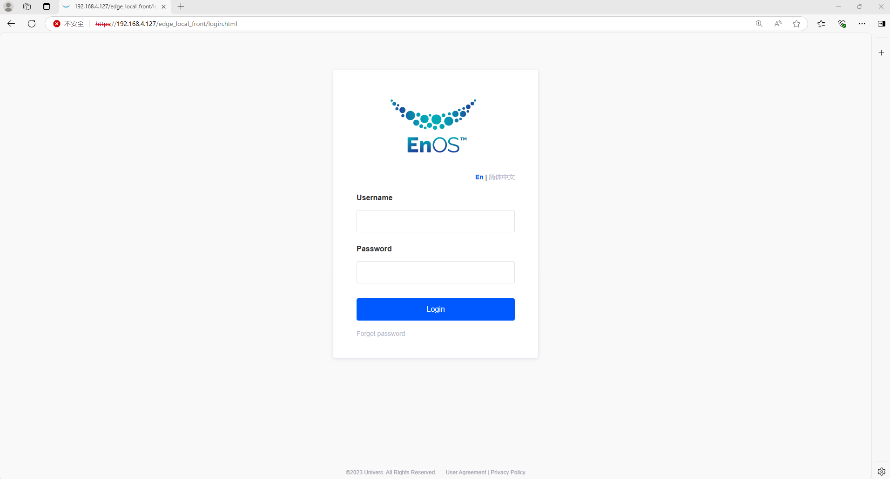
You can also log in to the local operations interface through Local Tools in the Dev Portal.
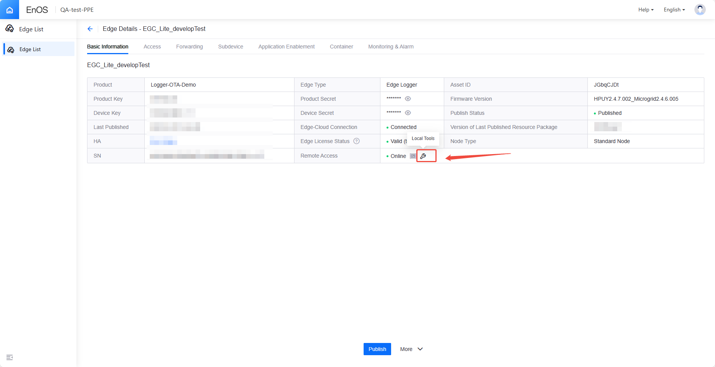
APP Portal Login (For EGC STD)
Connect to the microgrid controller network port locally and enter the connected network port IP in your browser to log in to the APP portal.
The APP portal username and password are created during the deployment of the APP portal. You can also log in with the administrator account for account registration and permission allocation.
Administrator account username: System, Password: EnOS@2019.
The APP portal features EGC Site Dashboard, M&C Monitor, Alarms, and EGC Control Strategy, among other functionalities.
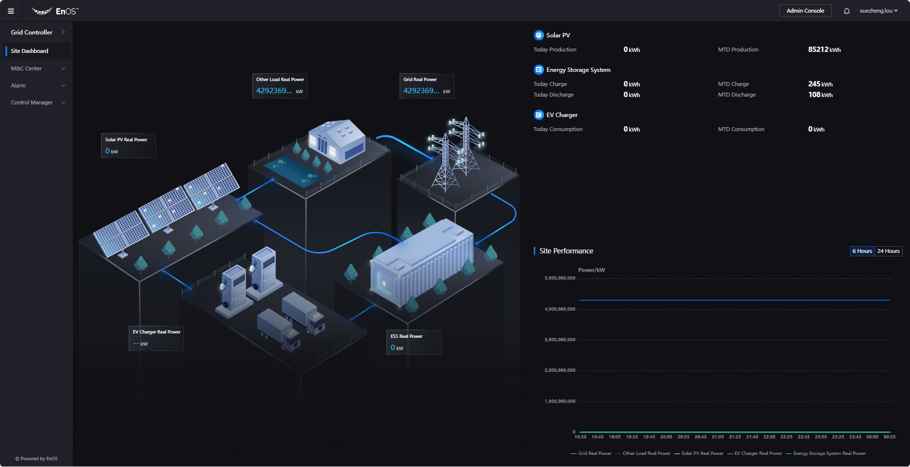

1.2 EGC Strategy Configuration

1.2.1 Creating Control Strategy
- After completing the Edge and corresponding device access work, log in to the Dev Portal.
- Navigate to Edge Application → Edge Grid Control → New Strategy.
- After configuring the strategy, click Confirm to save the strategy.
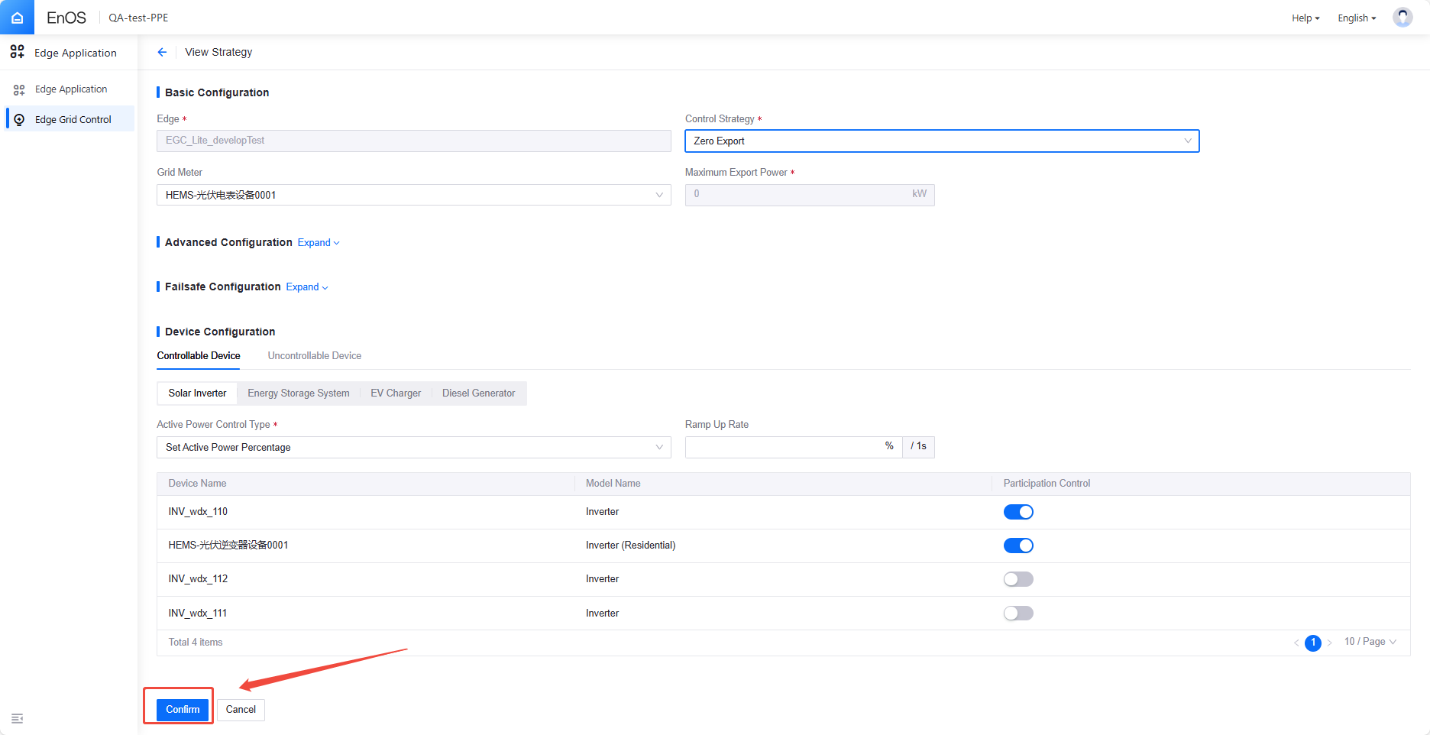
- After creating the strategy, click Enable.
- The system will perform a self-check on the EGC strategy configuration.
- If the self-check failed, please follow the fix suggestions provided to resolve any issues.
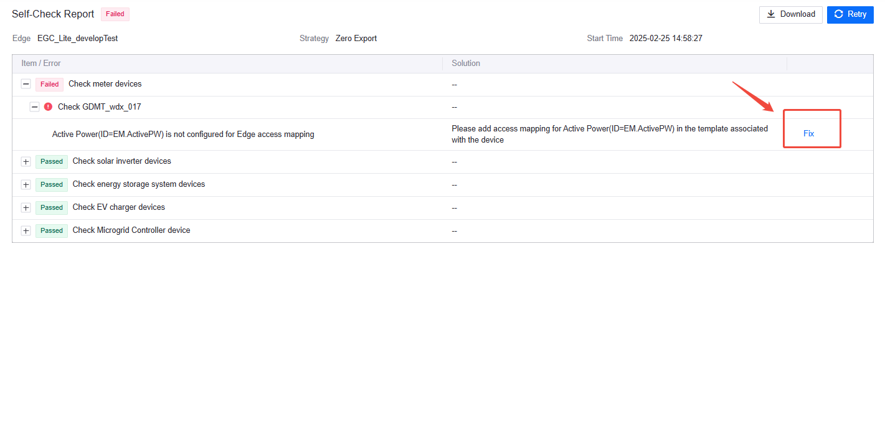
- After enabling the strategy, the Edge Logger will trigger an automatic publish. If the automatic publish does not occur, you can manually click Publish.
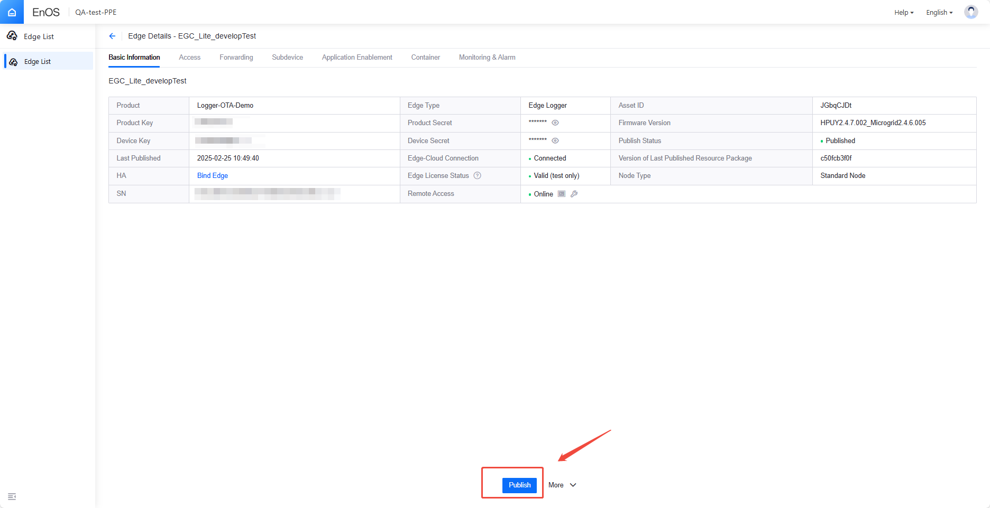

Local Operations Interface Configuration Control Strategy
- Log in to the local operations interface. Navigate to Microgrid Control.Before configuring, ensure to disable the strategy first.
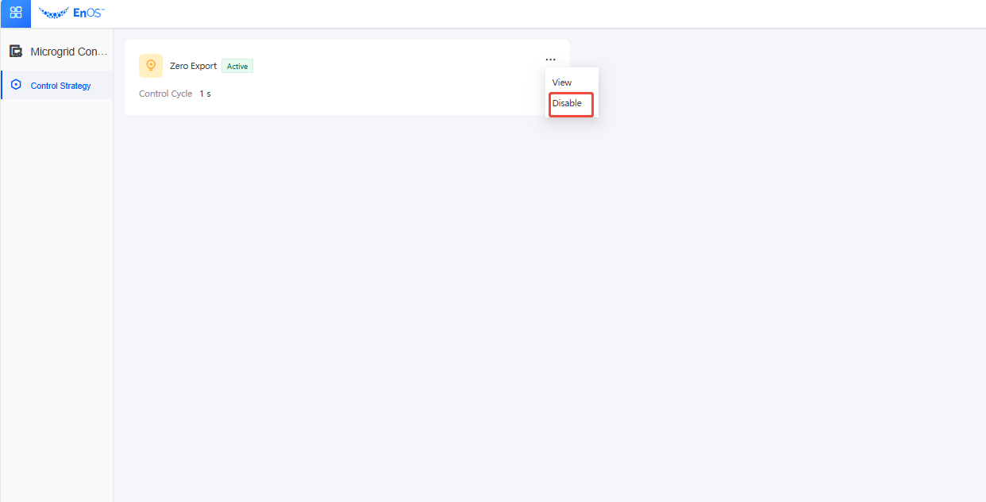
- After modifying the control strategy, you can enable the strategy again.
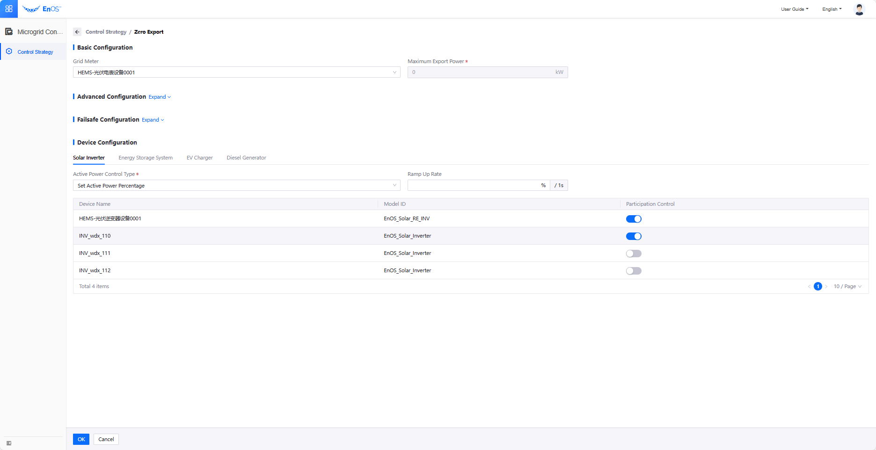

1.3 Modify Log Level
- The EGC log level configuration file is located:
EGC Lite: /root/EMS/edge-ems/resources/log.properties.
EGC STD: /home/envuser/energy-os/edge-ems/resources/log.properities
- The default level is set to INFO. Generally, it should be modified to DEBUG as needed. Changes take effect immediately upon saving.
- Steps to Modify the Log Level:
- Open the file, vi /root/EMS/edge-ems/resources/log.properties
or vi /home/envuser/energy-os/edge-ems/resources/log.properities
- Press i to enter edit mode.
- After edit operation, press Esc, then type :wq and press Enter to save and exit. If you didn't make any changes, type :q to exit without saving.
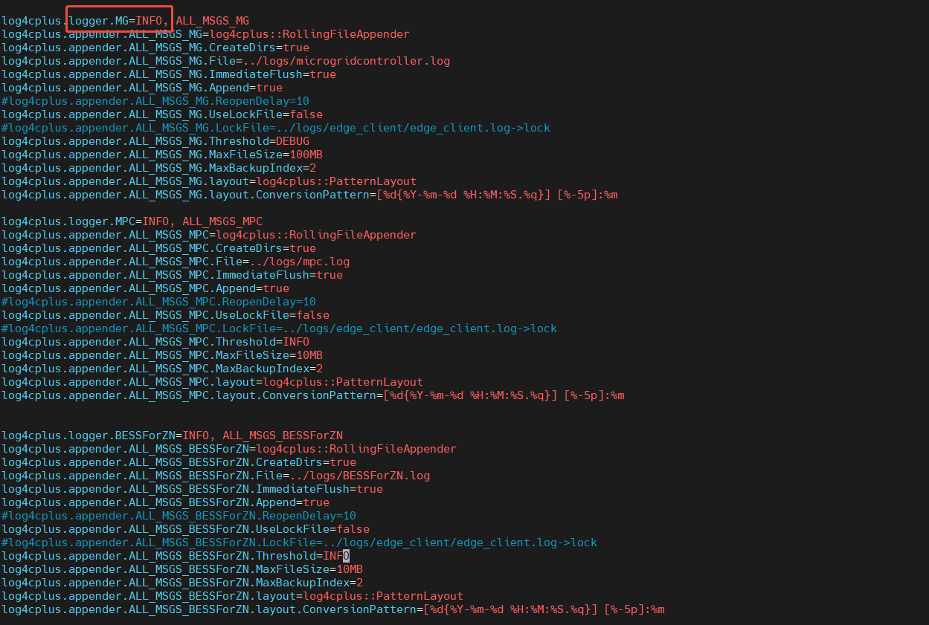
- After changing the log level from INFO to DEBUG, the EGC logs will display more detailed log information for operations and development personnel to analyze.
When the log level is set to INFO, the output in microgridcontroller.log is as follows:
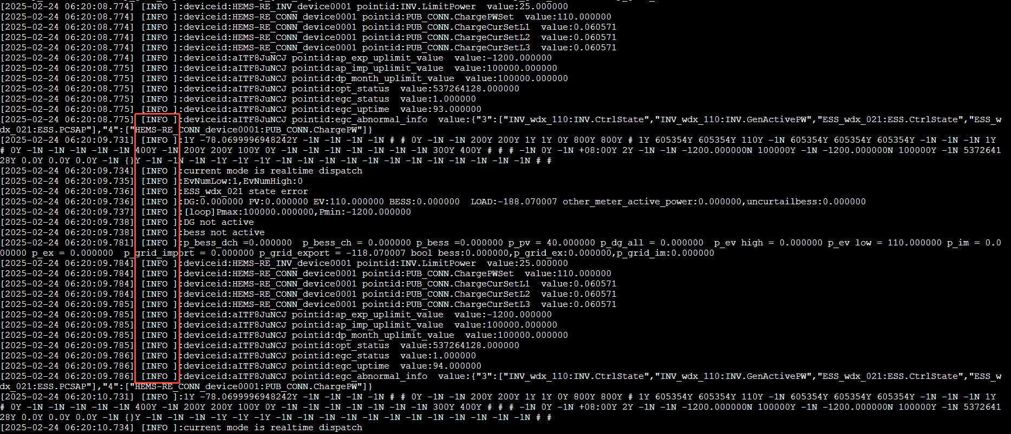
When the log level is set to DEBUG, the output in microgridcontroller.log is as follows. The log output will include additional detailed EGC-related log information on top of the INFO level output:
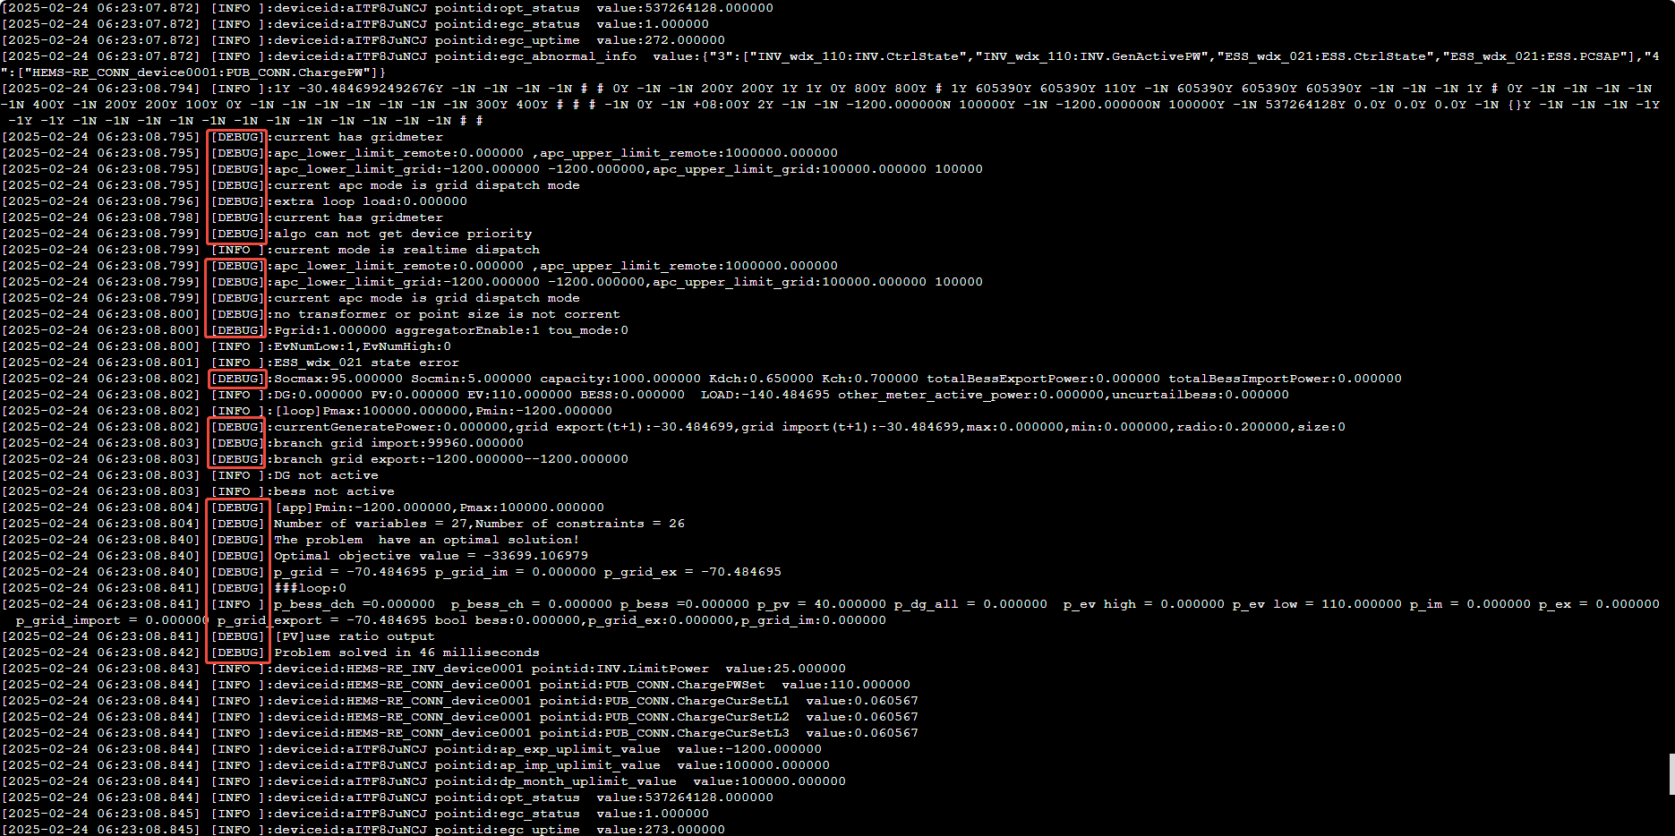

1.4 Restart EGC
If EGC is not running, you can execute the following command to check whether the EGC component is active:
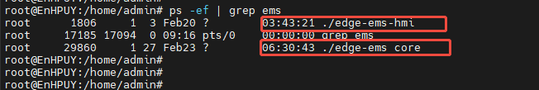
To restart the EGC algorithm, you can SSH or use rtty to access the device. Then, navigate to the EGC bin directory and execute the following command:
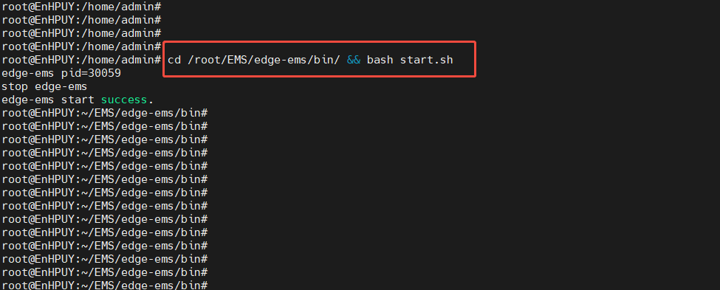
[For EGC STD]
you can SSH or use RTTY to access the box, navigate to the EGC bin directory, and switch to the envuser user. And execute bash start.sh.
To switch users: su envuser
Navigate to the EGC bin directory: cd /home/envuser/energy-os/edge-ems/bin/


1.5 Check EGC Strategy Running Status
In the Dev-Portal, navigate to the Edge Microgrid Control section to view the running status of the EGC Strategy. The statuses can be categorized as Normal, Sub-healthy, or Fault. By clicking on "View Details," you can access status information, including detailed status descriptions, issue checks, and handling methods. (Note: The sub-healthy status has been removed in versions after 330.)
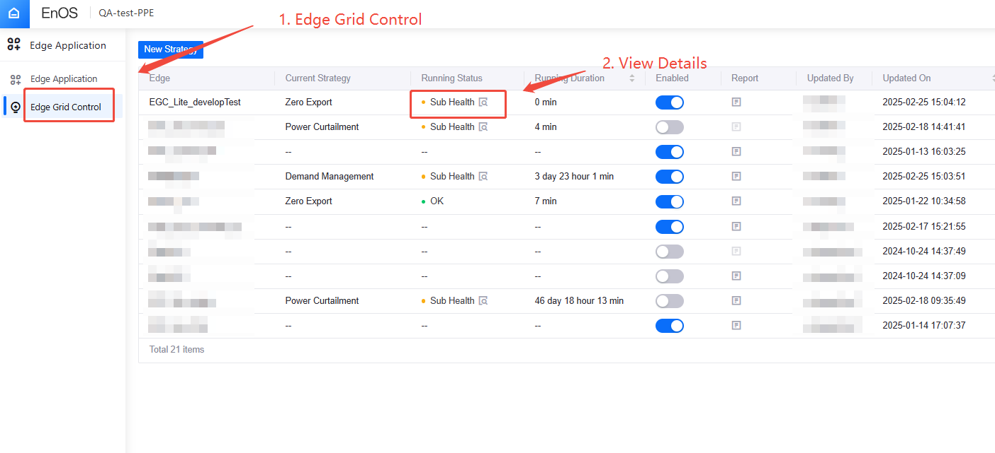
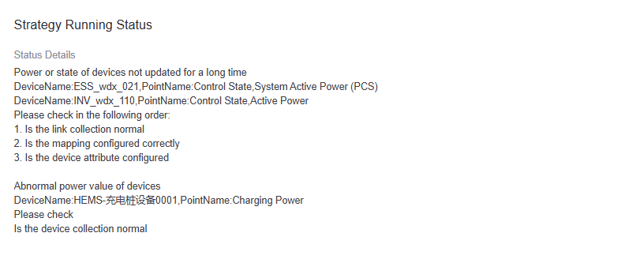

1.6 View EGC Logs
- The path for EGC-related log files is: /root/EMS/edge-ems/logs/
- To view the corresponding log file, use the command：tail -f /root/EMS/edge-ems/logs/xxxx.log
Press Ctrl + C to stop the dynamic log updates.
- The most common log file is microgridcontroller.log, which provides information about the currently running EGC policies and detailed information about their execution.
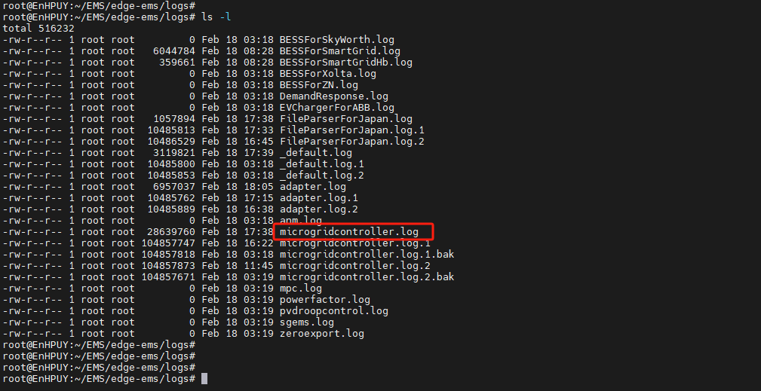
- Below, we will use microgridcontroller.log as an example to introduce some key metrics in the log (these metrics are planned to be displayed in Prometheus in the future):
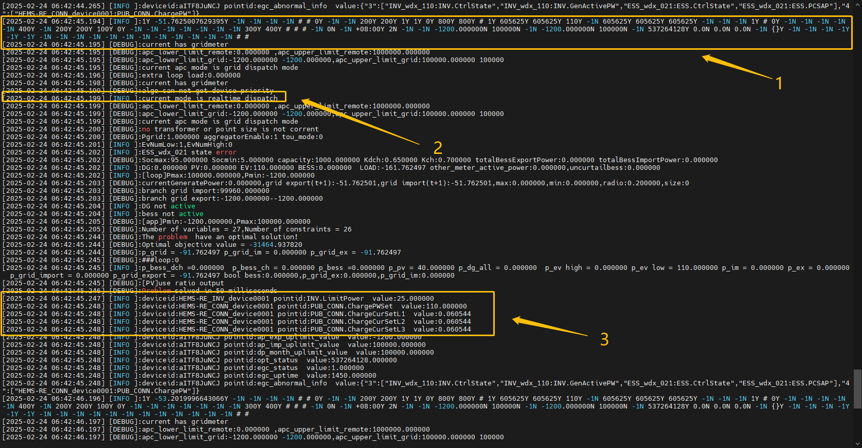
- The log information displayed in the yellow box 1 shows the attributes and measurement point information of the sub-devices connected to the EGC (such as Meters, Photovoltaics, Energy storage, EV Charger, and Diesel generators) (specific values can be queried based on app.config).
- The log information displayed in the yellow box 2 shows the current EGC strategy, with the current mode indicated as "realtime dispatch."
- The log information displayed in the yellow box 3 shows the EGC control output values, including DeviceID, PointID, and Value.

1.7 View EGC Application Status
Step1：Go to Edge List ，Click View > Monitoring&Alarm > Application
Step2：In the Application Monitoring page, you can view the applications under this Edge device.
Step3：Click the "View" button on the right side of the target application to see the details of the edge-ems sub-application monitoring metrics.
Currently, there are two application alarms in EGC:
EGC status egc_status=1 for 20 minutes continuously triggers an unhealthy alarm.
EGC status egc_status=2 for 20 minutes continuously triggers a fault alarm.
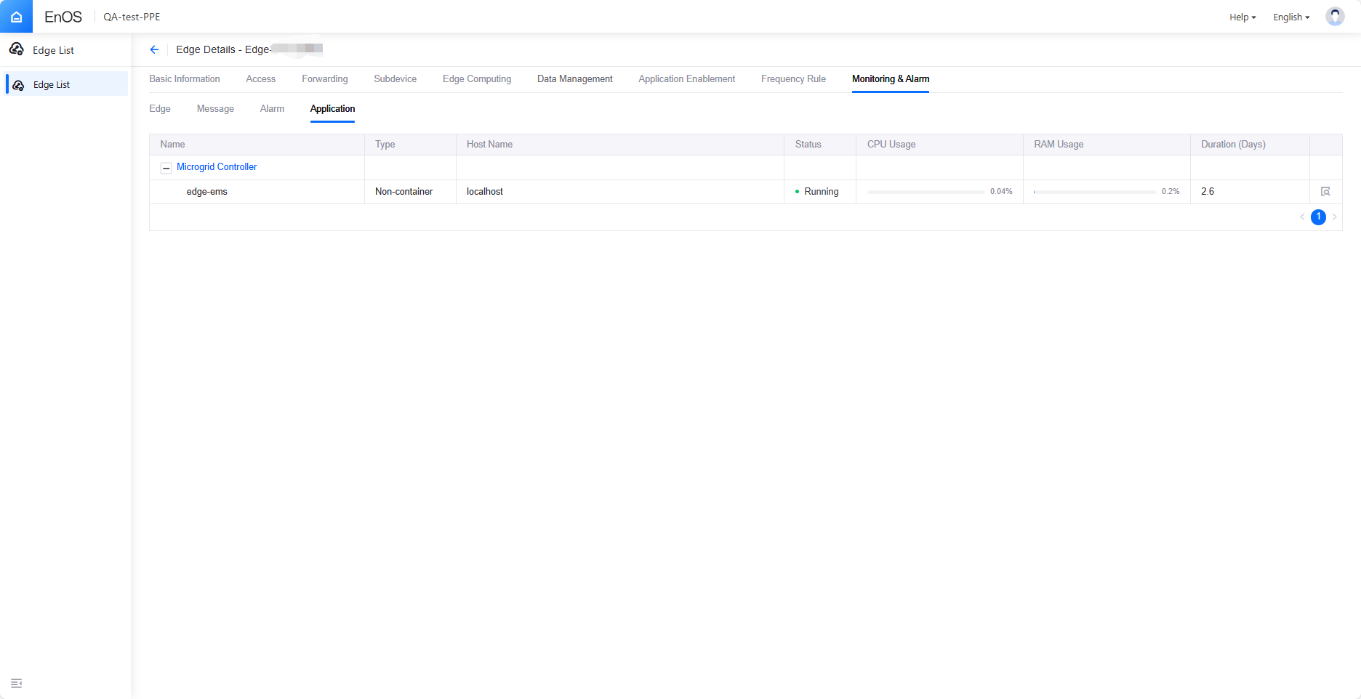

Case Analysis
This section focuses on a detailed analysis of specific EGC Lite cases, along with corresponding handling methods.

2.1 Failed to Load Control Strategy Library (Fault)
Phenomenon Description:
- Algorithm library does not exist.
- No permission for the algorithm library.
- Incorrect format of the algorithm library (e.g., x86/arm).
Troubleshooting Steps:
- Check if the algorithm library file exists.
- Check if the algorithm library file has read, write, and execute permissions.
Handling Method:
Execute the EGC Lite installation script to redeploy EGC Lite. After a successful deployment, enter the Dev-Portal to recreate and enable the control strategy, and then execute the release.

2.2 Failed to Load Control Strategy Library Configuration (Fault)
Phenomenon Description:
- File does not exist.
- File has no permissions.
- Indicates that the app.config format is incorrect.
Troubleshooting Steps:
- Check if the configuration file app.config for the algorithm library exists.
- Verify that the configuration file has read permissions.
- Ensure that the fields in the file are correct.
Handling Method:
Execute the EGC Lite installation script to redeploy EGC Lite. After a successful deployment, enter the Dev-Portal to recreate and enable the control Strategy, and then execute the release.

2.3 Device Power or Status Not Updating for an Extended Period
Phenomenon Description:
- Unable to retrieve key data (link status, controllable status, power, etc.) for an extended period (30 minutes).
- Checking the Strategy running status indicates that the device power or status has not been updated for a long time.
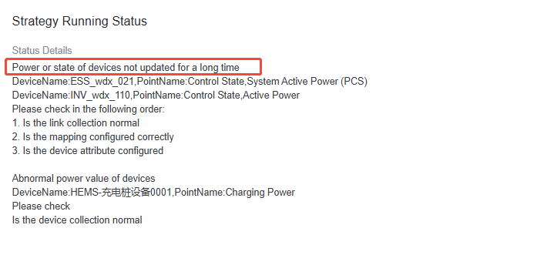
Troubleshooting Steps:
- Check if the link collection is functioning normally.
- Verify that the mapping is configured correctly.
- Ensure that the device attributes are properly configured.
Handling Method:
- Inspect the link collection for any issues.
- Review the template point table information for devices such as meters, inverters, EVs, ESS, and diesel generators to confirm that key data (controllable status, active power) is being collected correctly.

2.4 Anomalous Power Values for Controllable Devices
Phenomenon Description:
- Real-time power exceeds rated power.
- Real-time power shows data but is less than 0 (excluding energy storage and outlet meters).
- Grid input limit is less than output limit.
Troubleshooting Steps:
- Check if the device data collection is functioning normally.
Handling Method:
- Inspect the attributes of devices such as meters, inverters, EVs, ESS, and diesel generators to ensure that required attributes contain correct data.
- Review the template point table information for these devices to confirm that key data (controllable status, active power) is being collected correctly.

2.5 Control Strategy Configuration Error (Fault)
Phenomenon Description:
Checking the Strategy running status indicates that there is a control Strategy configuration error.
Troubleshooting Steps:
Please check if the maximum power consumption and maximum grid export power configurations in the control Strategy are correct.
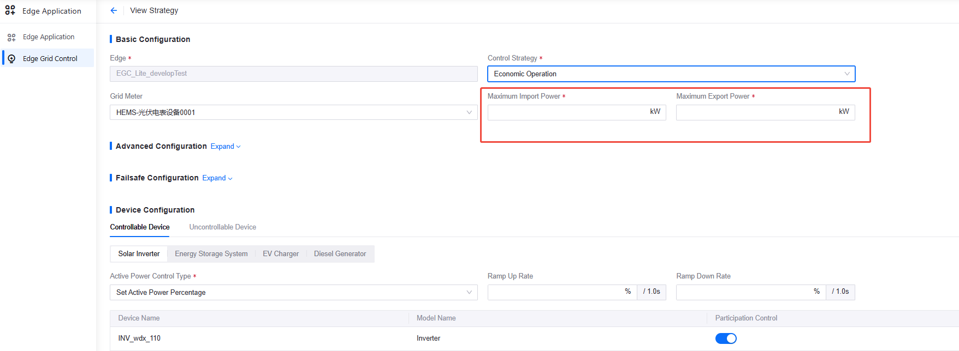
Handling Method:
Modify the control Strategy, enable the control Strategy, and execute the release.

2.6 Optimal Control Strategy Solution Failure (Fault)
Phenomenon Description:
Checking the Strategy running status indicates that the optimal control Strategy solution has failed, and the EGC algorithm has no solution.
Troubleshooting Steps:
Modify the EGC log level configuration file, changing the log level of microgridcontroller.log to DEBUG. Execute the following command to view the EGC logs:
tail -f /root/EMS/edge-ems/logs/microgridcontroller.log
Handling Method:
Download the microgridcontroller.log file and contact the EGC Team for issue analysis.

2.7 Device Control Request Dispatch Failure (Fault)
Phenomenon Description:
Checking the Strategy running status indicates that the dispatch of device control requests has failed.
Troubleshooting Steps:
Check if the data collection link is functioning normally.
Verify that the control point mapping is correct.
Handling Method:
Inspect the data collection link for issues, check the mapping of the corresponding device AO points, and confirm before re-releasing.

2.8 Meter Communication Interruption (Fault)
Phenomenon Description:
Viewing the EGC Strategy running status in Dev-Portal shows a fault. Clicking to view details displays a communication interruption with the meter.
Troubleshooting Steps:
In Dev-Portal, check if the connection status of the outlet meter under the corresponding Edge device is connected.
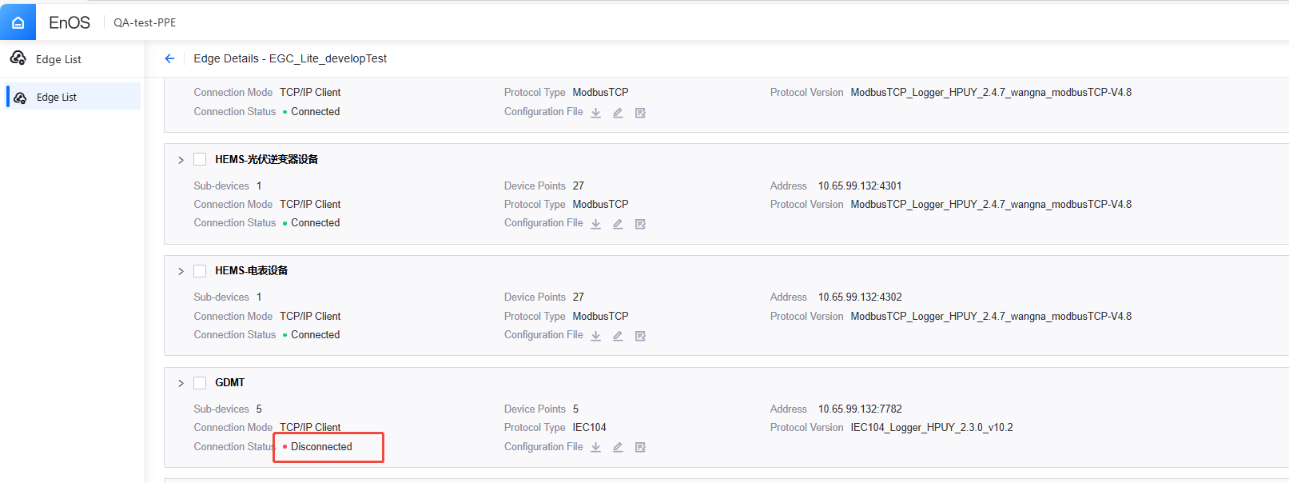
Enter the outlet meter device details, check the measurement points, and verify if the active power measurement point data is updating.
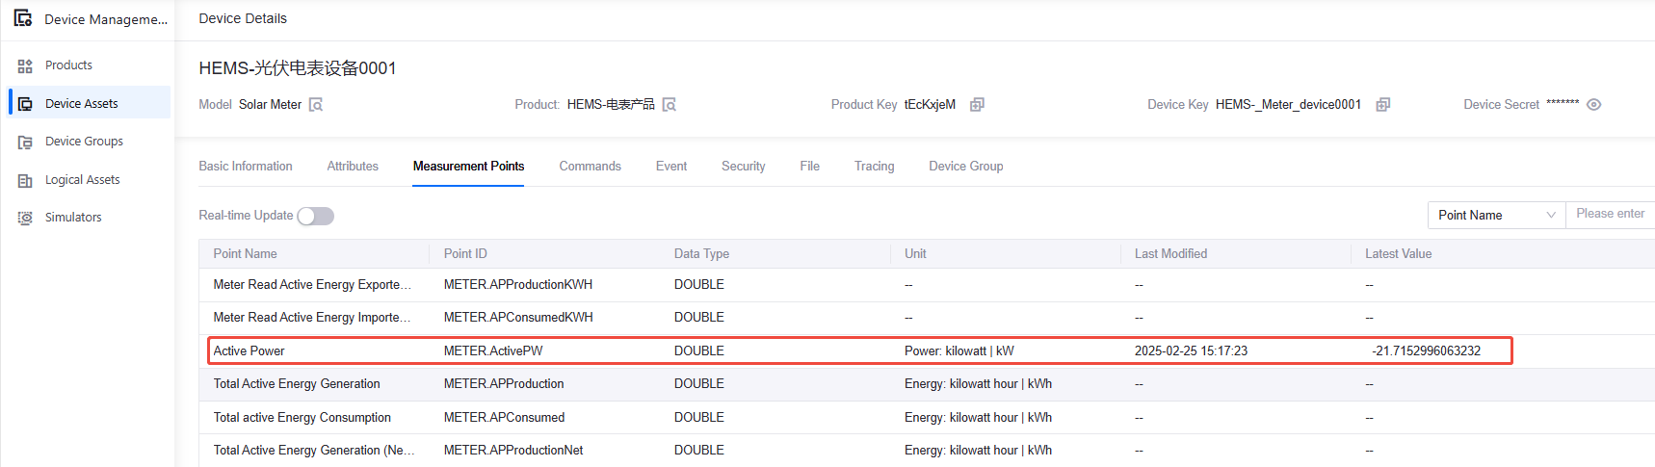
Handling Method:
- If the connection status of the outlet meter shows an interruption, check if the connection configuration is correct.
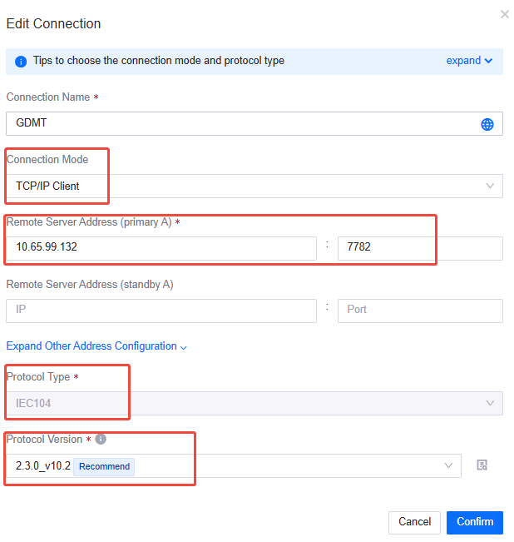
- If the connection status shows as not connected, but the active power measurement point of the outlet meter is not updating, verify that the outlet meter template is correct. For example, in the case of Modbus RTU, ensure that the device logical address, measurement point register address, and data type are accurate.

2.9 Control Plan File Related Issues (Fault)
When the EGC control strategy is set for grid power limitation (primarily used in Japan's EGC scenarios), it is necessary to configure the correct Curtailment File Pull server. The specific steps are as follows:
- Create a Curtailment File pull connection in Dev-Portal:
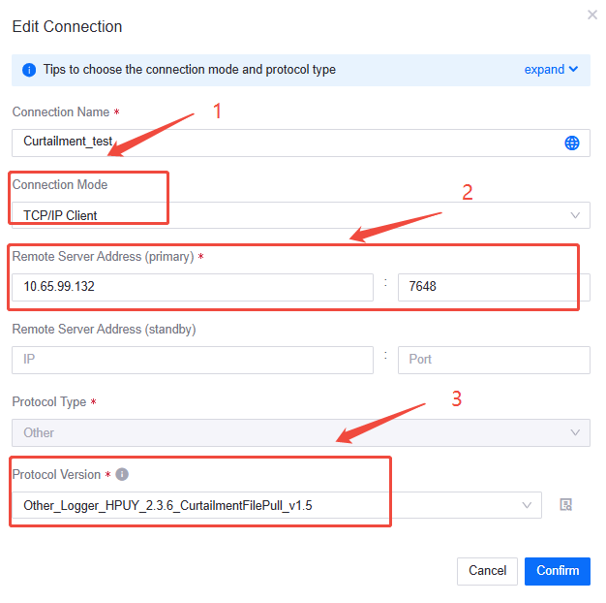
- Ensure that the Curtailment file is pulled successfully.
Execute: ls -l /data2/fe_protocol_data/curtailment
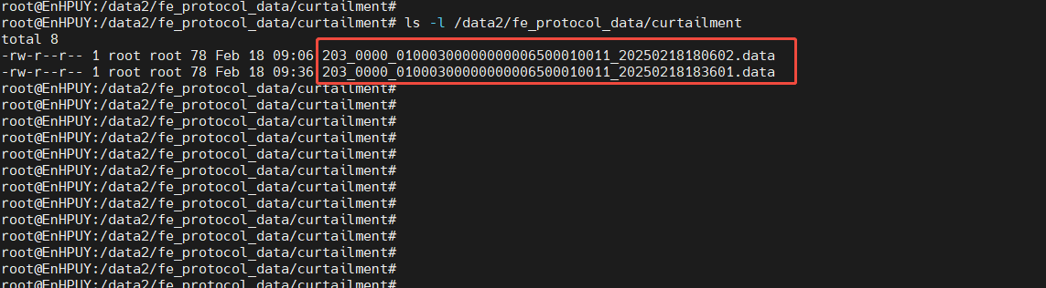
- Check the Curtailment file parsing log to ensure that the Curtailment file is parsed correctly:
cd /root/EMS/edge-ems/logs/ && tail -f FileParserForJapan.log
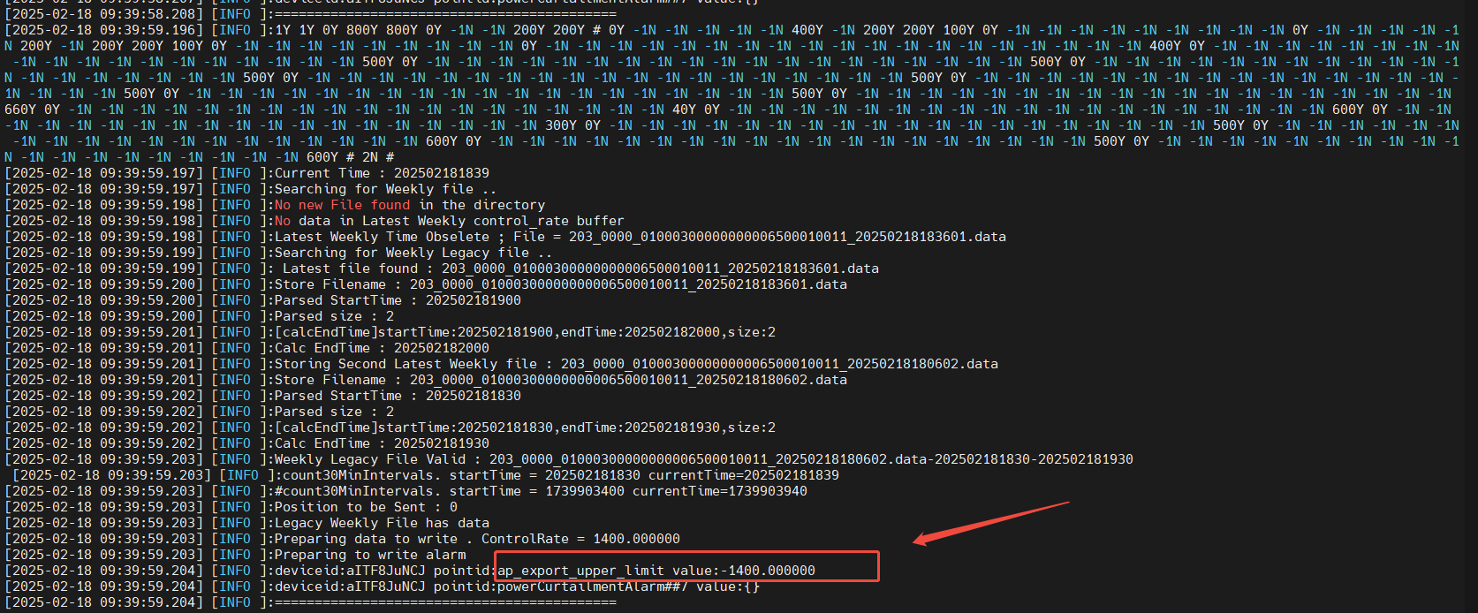

2.9.1 Control Plan File Name Format Error
Phenomenon Description:
Viewing the EGC Strategy running status in Dev-Portal shows a fault. Clicking to view details indicates that there is a format error in the plan file name.
Troubleshooting Steps:
- Check if the Curtailment file exists in the /data2/fe_protocol_data/curtailment/ directory.
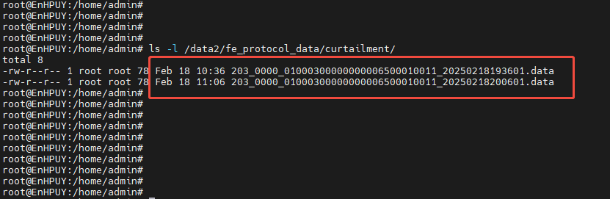
- Verify whether the update time of the Curtailment file is the latest, and check if the file name format is correct. For the naming rules and file content format of the Curtailment file, please refer to .
Naming Specification for Curtailment File: FileType_0000_StationID_YYYYMMDDHHMMSS.data
Handling Method:
- Check if the Curtailment file pull connection configuration is correct:
  - Connection Mode: TCP/IP Client
  - Remote Server Address: IP address of the Curtailment server, and correct port
  - Protocol: Other_Logger_HPUY_.3.6_CurtailmentFilePull_v1.5
[Note]: The protocol may be updated; select the latest version of the CurtailmentFilePull protocol.
- Restart the CurtailmentFilePull protocol.
Find the Curtailment process ID: ps -ef | grep Curtailment
To kill the Curtailment process ID: kill xxx (replace xxx with the actual process ID)
After killing the curtailment process, it will automatically restart. You can use ps -ef | grep Curtailment again to check.
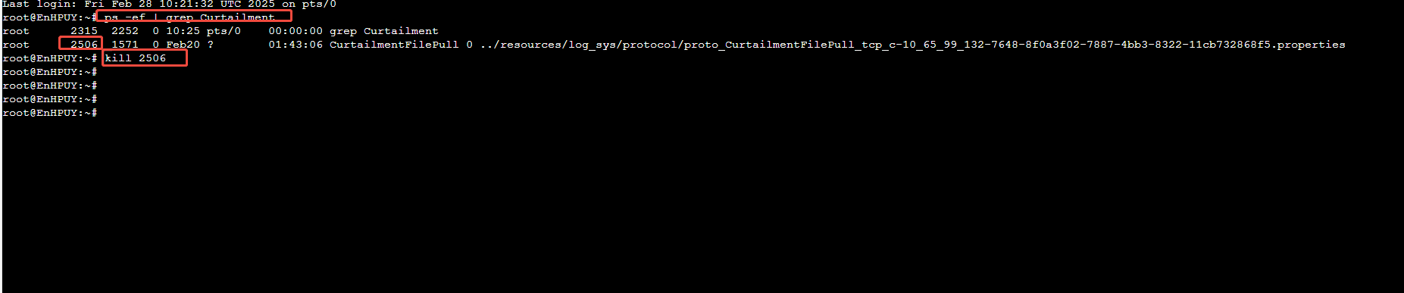

2.9.2 Control Plan File Content Incomplete
Phenomenon Description:
In Dev-Portal, viewing the EGC Strategy running status shows a fault. Clicking to view details indicates that the control plan file content is incomplete.
Troubleshooting Steps:
Download the corresponding Curtailment file and open it using Notepad++ (view in HEX) to check if the file content is complete.
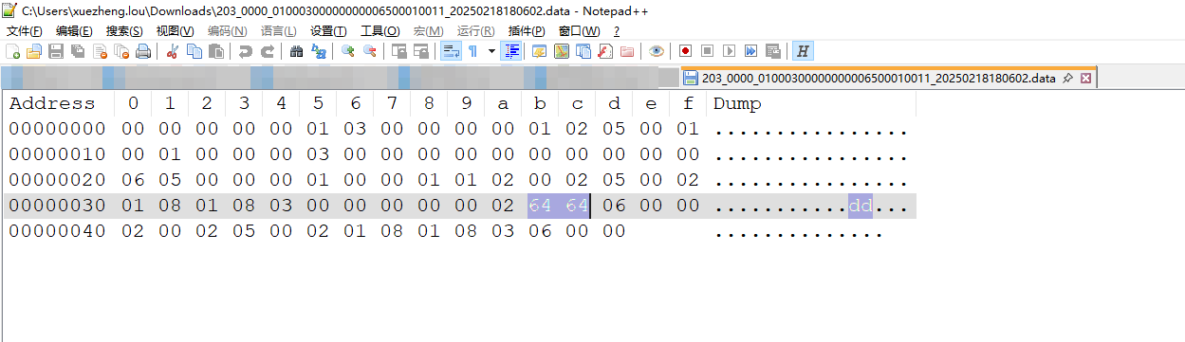
Handling Method:
Restart the CurtailmentFilePull protocol.

2.9.3 Control Plan File Content Incomplete
Phenomenon Description:
In Dev-Portal, viewing the EGC Strategy running status shows a fault. Clicking to view details indicates that the control plan file content is incomplete.
Troubleshooting Steps:
Download the corresponding Curtailment file and open it using Notepad++ (view in HEX) to check if the file content is complete.
Handling Method:
Restart the CurtailmentFilePull protocol.

2.9.4 No Matching Control Plan Found for Current Time Period
Phenomenon Description:
In Dev-Portal, viewing the EGC Strategy running status shows a fault. Clicking to view details indicates that no matching control plan was found for the current time period.
Troubleshooting Steps:
Download the corresponding Curtailment file and open it using Notepad++ (view in HEX) to check if the file content includes the control plan for the current period.
Handling Method:
Restart the CurtailmentFilePull protocol.

2.10 App Portal (For EGC STD)
2.10.1 No Data Display
Description of Phenomenon:
Key sub-devices or grid connection points show no data in the App portal. For example, it displays as –kw.
Troubleshooting Steps:
- Check if the unit devices have been created (not required after version 2.4.7).
- Verify if the data for each sub-device is normal.
Resolution:
For versions prior to 2.4.7, if the unit devices have not been created, proceed to create them. Refer to section 2.3 for sub-device checks.

